Programming Assignment Exp 9 Screen Shot Proofs

PROBLEM 1:

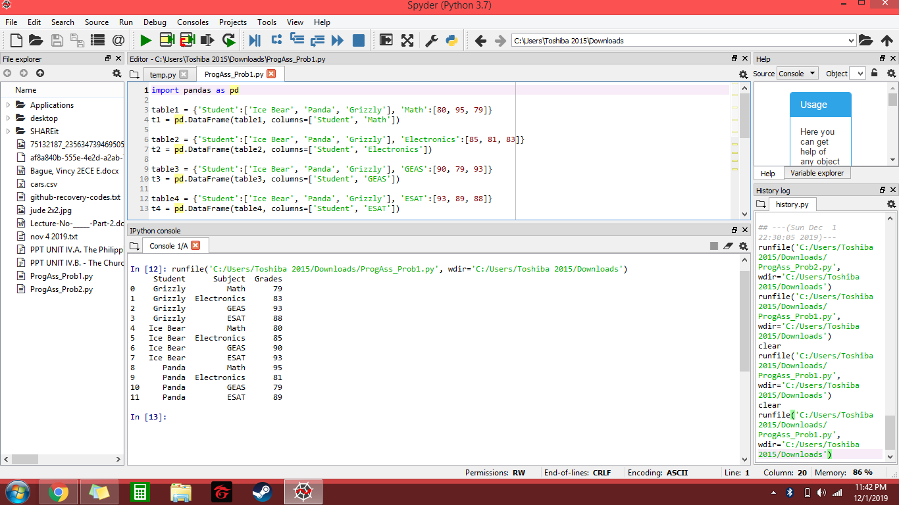

PROBLEM 2:

